Ferntree
Gully
Baptist
Family
Church

GOOD FRIDAY – 30th March
Theme – COLOURS of EASTER
Time - 9.30 to 11.30am
17 Hunter Street, Ferntree Gully

Come and join us on Good Friday morning. There will be an animal farm, face painting, jumping castles, hot cross buns, carpenters workshop, tea/coffee/cordial, craft. A special guest this year will be Lynton Allen, artist and storyteller. Come as a family and enjoy quality time on Good Friday 30th March.

Also
Easter Sunday Celebration
10am on Sunday 1st April

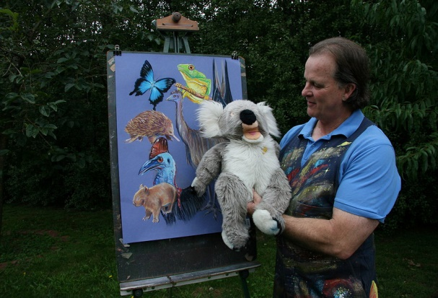
For more information call
Tony 0406 686715

